PGSuper Bridge Geometry Enhancements

Introduction
This document describes proposed enhancements to the geometric modeling capabilities of PGSuper. The purpose of these enhancements is to capture complex bridge geometrics making it easier for the engineer to accurately model actual bridges. The proposed enhancements can be generally classified as framing plan geometry and deck geometry.

There are situations where it is desirable to have different types of girders within the same structure. One example is a voided slab bridge. For this type of bridge it is common to make the central girder (or the exterior girders) different widths than the other girders to achieve a specific bridge width.

Another example is widening an existing bridge. The girder type used in the original structure may no longer be available or they are less efficient than modern sections. For example, a bridge constructed from W42G girders may be more efficiently widened using WF42G girders because they can be placed at a wider spacing resulting in fewer girder lines.

A third example is a multi-span bridge where a different size of girder is used in each span. Other practical examples exist.

Framing Plan Geometry
The framing plan geometry enhancements described in this section will allow engineers to model complex girder framing arrangements. Presently, PGSuper is limited to framing systems consisting of equally spaced parallel girder lines. Capabilities will be added to model framing systems with flared girder lines, non-uniform spacing, and different number of girder lines per span.

Analysis will be limited to simple spans for bridges having a different number of girders lines in each span.

Girder spacing may be measured at the centerline of bearing or the centerline of pier/abutment as shown in Figure 1. The location of the centerline of bearing is defined by the pier geometry connection. Girder spacing may be measured along the centerline (bearing or pier) or normal to the alignment at the intersection of the centerline (bearing or pier) and the alignment. For the purpose of these enhancements, the centerline bearing will be constrained to be parallel to the centerline of pier.
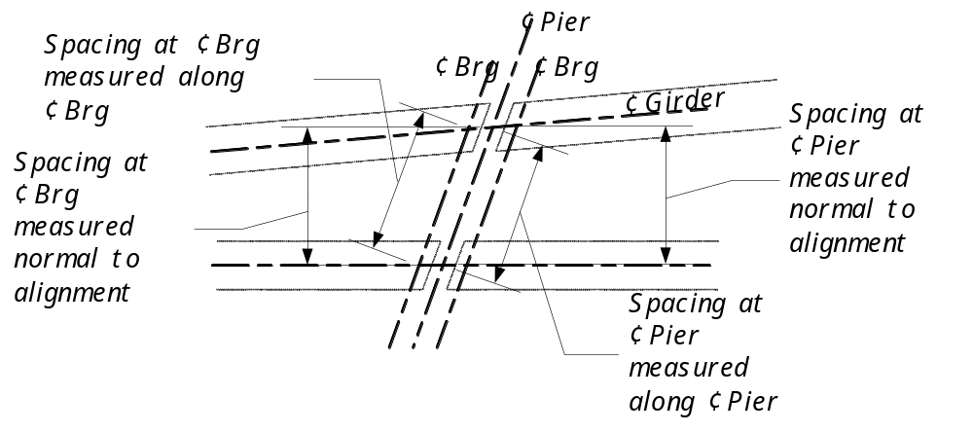
Figure 1 - Girder spacing

Deck Geometry
Coupled with complex framing plans is complex deck geometry. PGSuper currently models the edges of the deck as parallel to the alignment. Deck widths are defined by girder spacing and overhangs. This is an inadequate model for bridges with splayed girders and tapering roadway widths.

The deck geometry model will be replaced with one based on roadway width. The deck will be described by a series of curb-to-curb widths defined at various stations along the alignment. The curb-to-curb width will be linearly interpolated between control points. For curved decks, the radius will be linearly interpolated between control points.

This deck model is similar to the model for describing superelevation transitions.

User Interface Changes
This section describes changes to the user interface that are necessary to support the enhanced framing features.

Concepts
Two new user interface concepts will be introduced with these proposed changes. Overlapping input is a concept whereby input data is described in all the logical places a user may look for it. For example, a user may reasonably look for girder spacing in both the pier definition and the span definition. To prevent the user from looking for this input in the “wrong” place, it will be available in both places.

The other new concept is linkage. The proposed changes make PGSuper a more flexible and robust program, however with this flexibility comes complexity. More data fields are required to describe the bridge as the assumptions regarding the girders, number of girder lines, and girder spacing have been generalized out of the software. However, it is important to keep the description of simple, regular structures as easy as possible. To this end, the concept of linkage is introduced. When piers, and thus the adjacent spans, have identical descriptions, only one pier needs to be defined in all of its detail. The other piers can be linked to this source pier and inherit the detailed input.

Structural Analysis Method
When the structural analysis is preformed for a bridge consisting of a different number of girders per span, PGSuper will post an issue in the status center if the structural analysis method is not Simple Span. To make changing the structural analysis method easy, the setting will be moved from the Project Criteria library to the main user interface. Agencies can still set the default structural analysis method by configuring their templates accordingly.

The Structural Analysis tab will be removed from the Project Criteria library entry. Project | Structural Analysis Method will be added to the main menu. This will open the Structural Analysis Method dialog shown in Figure 2. This dialog can also be accessed by double-clicking on the structural analysis method indicator in the status bar.
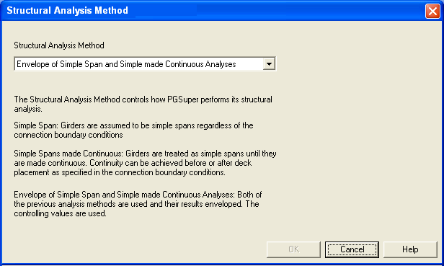
Figure 2 Structural Analysis Method Dialog

Pier Selection
Piers will be selectable objects in the Bridge Model Plan View. A pier will become selected when the left mouse is clicked on the pier object.

The following actions can be taken when a pier is selected.
- Enter Key Press – Opens the Pier Details dialog
- Double Click on Pier – Opens the Pier Details dialog
- Right Click – Displays a context menu for the pier. The menu options will be Edit Pier, Insert Span before this Pier, Insert Span after this Pier, Delete with Previous Span, and Delete with Next Span
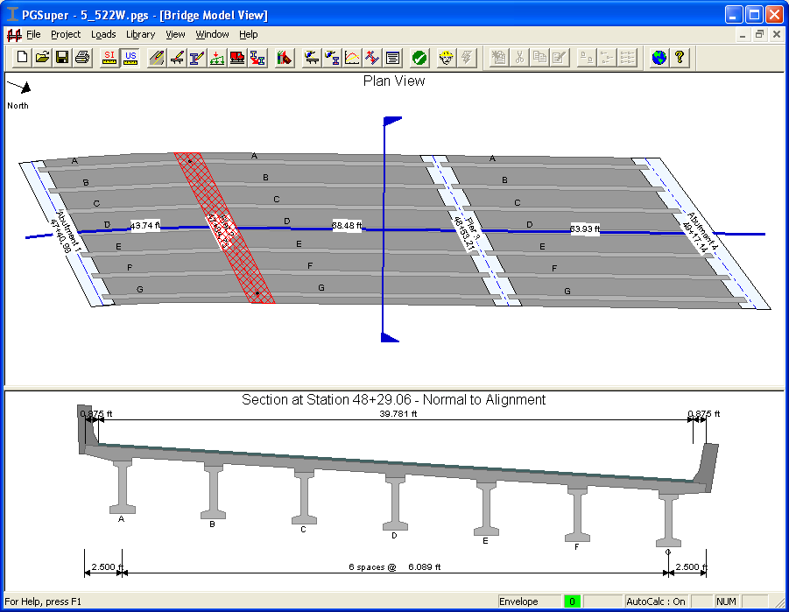
Figure 3 Selected Pier

Span Selection
Spans will be selectable objects in the Bridge Model Plan View. A span will be selected when the left mouse button is clicked within a span. If the mouse click is on a girder, a second click is required to select the span. An additional mouse click after the span is selected will select the deck.

Pressing the left and right arrow keys will move the selection from span to pier to span. Pressing the up and down arrow keys will change the selection from girder to span to deck.

The following actions can be taken when a span is selected.
- Enter Key Press – Opens the Span Details dialog
- Double Click on Span – Opens the Span Details dialog
- Right Click – Displays a context menu for the pier. The menu options will be Edit Span, Insert Span Before this Span, Insert Span After this Span, Delete with Previous Pier, Delete with Next Pier
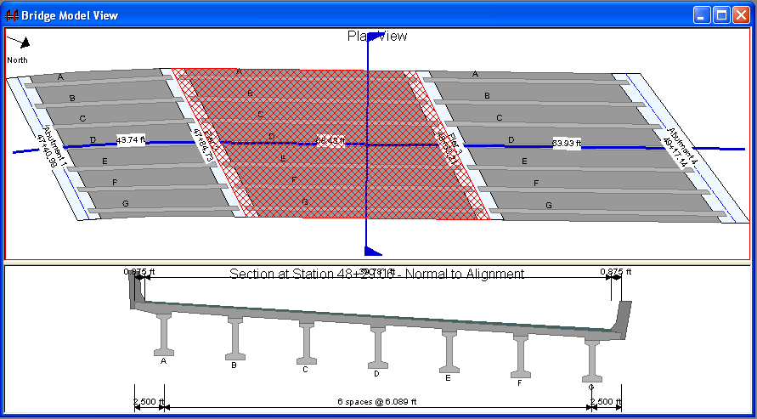
Figure 4 Selected Span

Bridge Description Dialog
The Bridge Description Dialog will be modified as described herein. A new tab, named General will be added. This tab will contain fields for the general description of the bridge. This tab has much of the data that was found on the Superstructure tab. The Superstructure tab is deleted.

General Tab
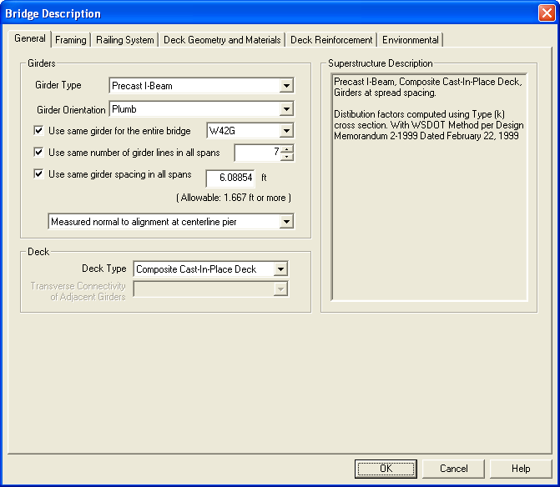

- Girder Type establishes the girder “family” used in the structure. All girders in the structure must be of the same general type (I-beam, Voided Slab, etc).
- Use same girder for the entire bridge. When checked, the Girder Name drop down is enabled and its selection defines the girder used for the entire structure. Girder Name options on the Pier Details and Span Details dialog will be disabled. If this option is not checked, then a different girder can be assigned to each girder line in each span.
- Girder Orientation defines the orientation of the girder (Plumb, Normal to Deck, etc)
- Use the same number of girder lines in all spans. When checked all spans have the same number of girder lines. The Number of Girder Lines control will be enabled and the Number of Girder Lines input on the Pier Details dialog and Span Details dialog will be disabled. Otherwise the Number of Girder Lines control is disabled and the number of girder lines is defined per span using either the Pier Details dialog or the Span Details dialog.
- Number of Girder Lines sets the number of girder lines in the structure.
- Deck Type is the name of the deck type system used in this bridge. It is a function of the Girder Type selected
- Transverse Connectivity of Adjacent Girders defines how girders are connected transversely if they are adjacent to one another. This is a function of the Deck Type and Girder Type selected.
- The label box provides a summary description of the bridge including cross section type used for live load distribution factor calculations

In summary, this tab is much like the former Superstructure tab with the additional capability of indicating the number of girder lines and/or the girder name can be different in all spans.

Framing Tab
The Pier tab will be renamed Framing as it now represents the framing plan. The Framing tab will be similar to what is shown in Figure 5. This tab is used to define the location of the piers, pier orientation, pier linkage, and pier details. Span details are also available on this tab. Span details include number of girders per span and girder spacing within the span.

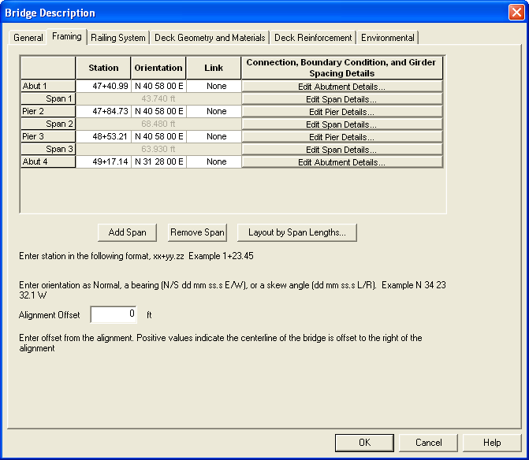
Figure 5 Framing Tab

The pier station and orientation are defined the same as in earlier versions of PGSuper.

The detailed descriptions of piers may be linked to one another eliminating the need for duplicate input. The Link column will show the linkage status. If a pier is linked, the orientation box will be made read-only if the pier orientation is linked to the source pier (see Pier Details Dialog below). It is required that one pier have a link type of “None”. This will be enforced in the user interface.

Pier details are edited by pressing the Edit Pier Details button in the Connection, Boundary Condition, and Girder Spacing Details column. This will open the Pier Details Dialog.

Span details are edited by pressing the Edit Span Details button in the Connection, Boundary Condition, and Girder Spacing Details column. This will open the Span Details Dialog.

Railing System
The railing system tab is used to defined the railing system used on the bridge. Railing systems can be defined for the left and right sides of the deck.

Check the sidewalk box to enable a sidewalk definition. This will also automatically enable the pedestrian live load.

If there is an interior barrier that separates the traveled lanes from the sidewalk, check the interior barrier box and select a barrier from the drop down list.
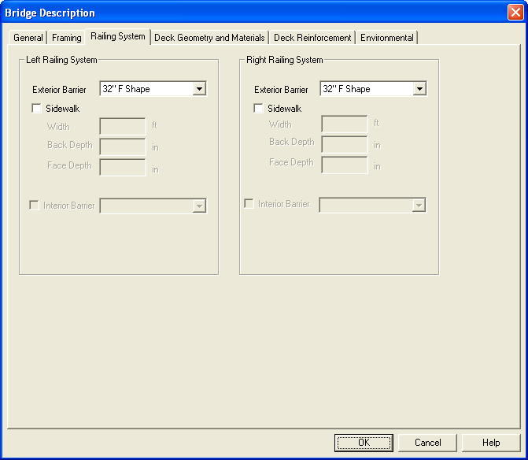
Figure 6 Railing System

Deck Geometry and Materials Tab
It is common for bridges with complex framing plan geometry, such as in urban interchanges, to have deck that vary in width.

The description of the width of the bridge deck will be changed from specifying left and right side overhangs to entering the curb-to-curb width of the deck at various stations along the alignment. The curb-to-curb width is measured normal to the alignment. The width of the deck varies linearly between control points. In curved sections, the edge of deck is curved with a linearly tapering radius (e.g. a transition spiral is used). This is similar to the method for defining superelevation transitions.

The Bridge Description Dialog, Deck Geometry and Materials tab will be reformatted as shown.
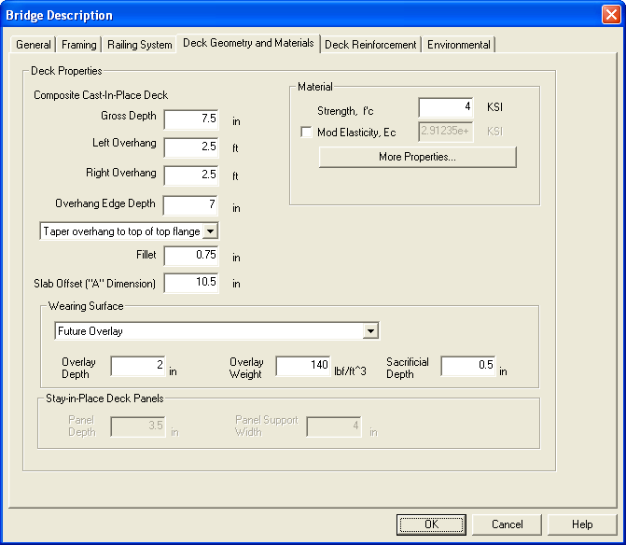
Figure 7 Deck Geometry and Materials

All of the input remains the same with the following exceptions:
- Left and Right Overhangs are removed
- A grid for entering the curb-to-curb width is added along with Add, Remove, and Sort buttons. A schematic drawing of the bridge section is shown that illustrates the curb-to-curb width.
- Only the essential properties of the deck concrete material are shown. The additional, and rarely used, properties are accessed by pressing the More Properties button.

The remaining tabs in this dialog remain unchanged.

Pier Details Dialog

Layout Tab
The Layout tab defines the general pier layout. This repeats the data found in the grid, but makes it available to the user if editing is activated through the selected pier object in the Bridge Plan View.

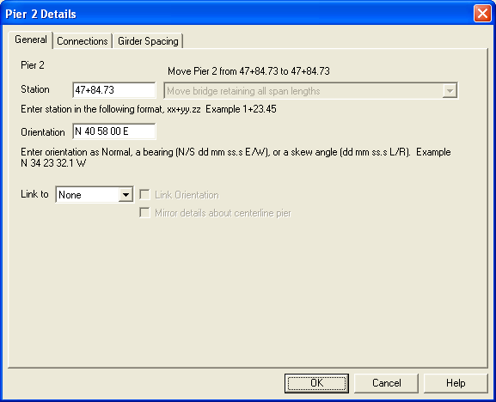
Figure 8 Pier Details Dialog - Layout Tab

The Station and Orientation fields are well defined in previous versions of PGSuper and will not be further described here.

If the pier station is modified the overall geometry of the structure is affected. The drop down list gives the user several choices for altering the bridge geometry. The choices are:
- Move this pier to the indicated station and retain all span lengths (move the bridge)
- Move this pier to the indicated station and adjust the length of the previous and next spans
- Move this pier to the indicated station, adjust the length of the previous span, and retain the length of all other spans
- Move this pier to the indicated station, adjust the length of the next span, and retain the length of all other spans

The linkage property can be set in this dialog. The definition of the connections and girder spacing may be different on the Back and Ahead sides of the pier. For a symmetric bridge, it may be desirable to link the definition of the first and last interior piers with the data for the Back and Ahead sides swapped. The mirror option will accomplish this.

The pier orientation can be linked to the source pier by checking the Link pier orientation box. This will make the orientation of this pier match that of the source pier. The orientation box in the Bridge Description Pier Grid will be made read-only if the pier orientation is linked.

If the pier is linked, all data except the pier station (and possibly the orientation) will be made read-only.

Connections Tab
The geometry and boundary condition of the girder to pier connection are defined on the connections tab. The various input parameters have not changed from earlier versions of PGSuper so they will not be described here.

If the Use same connection geometry and boundary conditions on both sides of the pier box is checked, the Ahead Side of Pier controls will be disabled and the will automatically be set to match the values for the Back Side of Pier (Exception: If the first pier is being edited, the Ahead Side will be enabled and the Back Side disabled).
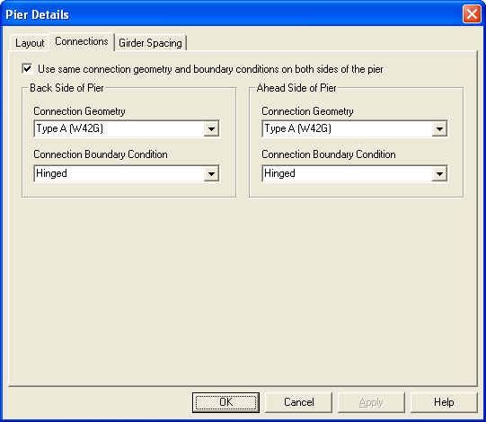
Figure 9 Pier Details Dialog - Connections Tab

Girder Spacing Tab
The girder spacing tab is used to define the girder spacing at a pier. The girder spacing may be defined independently for the Back and Ahead sides of the pier. If the Use same girder spacing on both sides of pier option is selected, the Ahead side will be disabled and all input on the Back side will be reflected in the Ahead side controls (Exception: If the first pier is being edited, the Ahead Side will be enabled and the Back Side disabled).

The number of girder lines on each side of the pier may be defined as well. If the number of girder lines is not consistent with the next/previous pier and is not consistent with the adjacent spans, the number of girder lines will be adjusted to match the input in this dialog.

If the general bridge model is defined such that the same number of girder lines are defined in all spans, the Number of Girder Lines fields in this dialog are disabled.

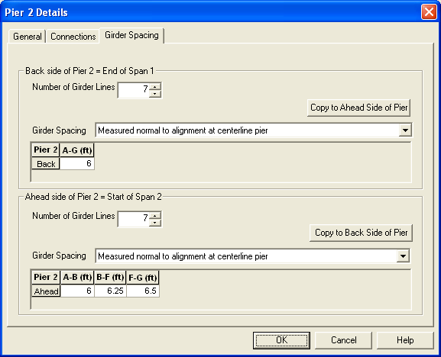
Figure 10 Pier Details Dialog - Girder Spacing Tab
The datum for measuring the girder spacing is one of the following:
- Measured along the centerline of bearing
- Measured along the centerline of pier/abutment
- Measured normal to the alignment at centerline of bearing
- Measured normal to the alignment at centerline of pier

By default, the grid has a single column labeled A-n where n is the identifier of the right exterior girder. The user can input uniform girder spacing in the single cell of the girder. This will define the spacing between all girders.

By selecting the column and choosing Expand from the grid context menu the grid to be reconfigured so that there is a column for each girder space. The columns will be labeled, A-B, B-C, C-D, and so on to indicate the space between girder A and B, B and C, etc. The user can now enter a different space between each pair of girders.

If there is a subset of girders that are at a uniform spacing, the user can select adjacent columns that represent the subset. The subset can be combined into a uniform spacing group by right clicking on the selected column headers and choosing Join from the context menu. The grid will be reconfigured with a mix of variable and uniform spacing entries.

For the example shown the Ahead side of the pier has three spacing groups. A-B and F-G are variable spacing and a uniform spacing is used for the subset B-F.

The spacing may be copied from one side of the pier to the other using the Copy buttons.

Since the grid operations aren’t immediately obvious to the user, tool tip text is provided when the mouse hovers over the grid. Descriptive examples will be given in the associated help topic.

Span Details Dialog

Layout Tab
The Layout tab defines the general span layout. If the span length is changed, the stations of the ahead piers will be adjusted.

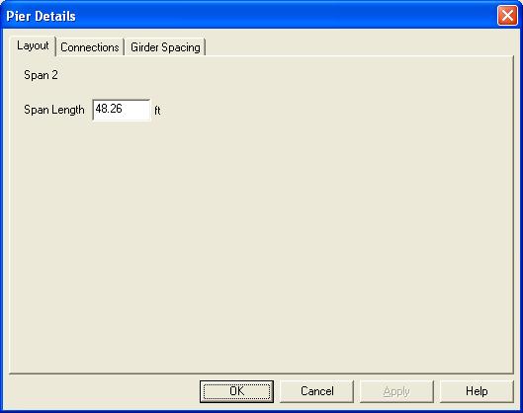
Figure 11 Span Details - Layout

Connections Tab
The Connections tab defines the connections at the start and end of the span. If the connection and boundary condition definitions are changed the definitions at the supporting piers are changed as well. If the connection definition at a pier applies to both sides of the pier, then changes to one side in this dialog will affect both sides of the pier. That is, the linking of the Ahead and Back sides of a pier will be maintained when editing a span.
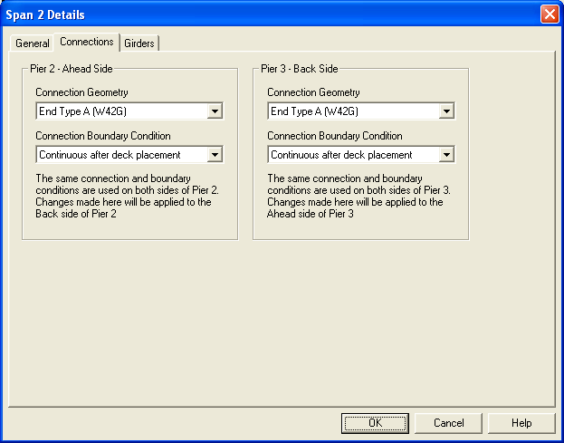
Figure 12 Span Details - Connections

Girders Tab
The Girders tab defines the girders and the spacing used in the span. Similar to the Connections tab, changes made on this tab are reflected in the Pier Details.

The spacing grid works exactly the same as the spacing grid in the Pier Details dialog. The girder name grid works similarly to the spacing grid. Girders can be grouped to assign the same girder name to several girders at once. Alternatively, each girder can be assigned a different name or all girders can be assigned the same name.
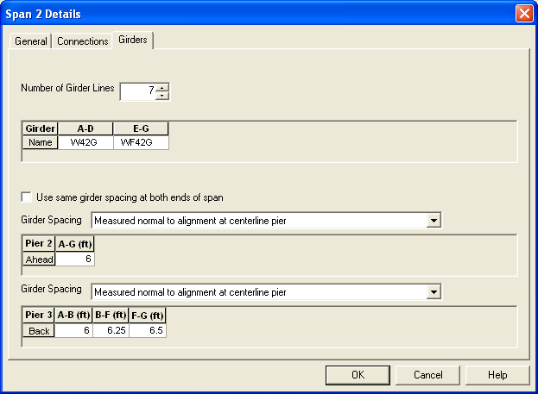
Figure 13 Span Details - Girder Spacing

Edit Girder Dialog
A General tab will be added. The general description of the girder is on this page. If the Girder Name is set for the entire bridge (see General tab of Bridge Description Dialog) the Girder Name field will be made read-only here. Otherwise, the name of the girder used for girder can be set.

Many of the concrete properties are set by default and are never changed by the user. To simplify input, these properties are moved to a details dialog. By pressing the More Properties button, the user has access to all concrete parameters as shown below (Note, the Concrete library entry dialog is shown here. The actual dialog used will be similar).

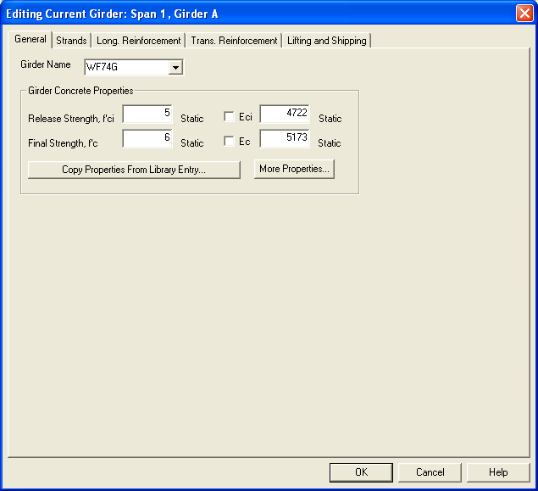
Figure 14 Edit Girder General Properties

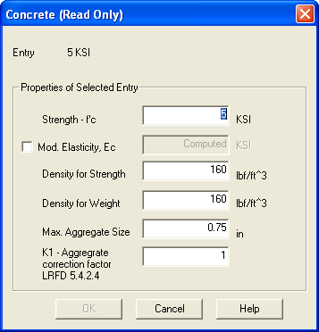
Figure 15 Concrete Properties
The Prestressing Strand Type will be moved to the Strands tab.
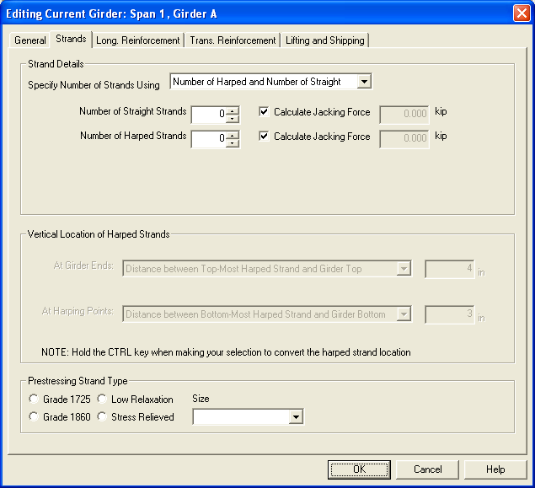

The Material tab will be eliminated.

The Edit Girder dialog will be made to accommodate editing of several girders at the same time. Selection of multiple girders is described below. For a given edit field, if the data value is the same for all girders being edited the value is displayed, otherwise the field is blank or, in the case of check boxes and radio buttons, the field is shown grayed and checked (this is the “tri-state” feature of these controls). Edits made to a field apply to all girders being edited.

Copy Girder Properties Dialog
Copy Girder Name will be added as a choice on the Copy Girder Properties dialog.

Project Criteria Library Entry
This more general framing plan input will lead to girder lines that are not parallel. The LRFD specifications require that girder lines be parallel however the commentary provides guidance for splayed girders. An angular deviation parameter is required to determine if adjacent girder lines are parallel enough to apply the simplified analysis method. This parameter will be added to the Bridge Site 3 tab in the Live Load Distribution Factors group as shown in Figure 16. If the bridge geometry is such that this threshold value is exceeded, live load distribution factors will have to be user defined.
The LRFD specification also requires that girders be of approximately the same stiffness for the simplified method of analysis. Approximately the same stiffness will be defined by a ratio of the minimum to maximum bending stiffness EI. EImin/EImax < K where K is a threshold value defined by the project criteria. If this threshold value is exceeded user defined live load distribution factors will be required. See Figure 16.

As described above, the Structural Analysis tab will be removed from the Project Criteria.

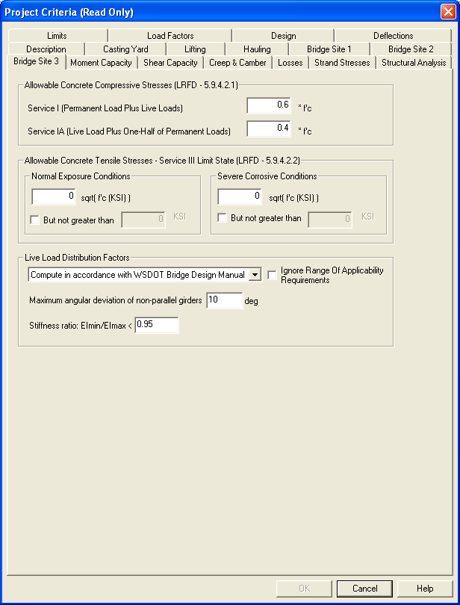
Figure 16 Project Criteria

Migrating Data Sets
The framing data in existing PGSuper files is uniform spacing measured normal to the alignment at the centerline of pier. The same spacing is used on both the Ahead and Back sides of the pier. This data is easily and accurately presented in this new user interface.

Caveats
The girder spacing will now be done independent of girder type. Because of this PGSuper can no longer display the minimum required spacing to avoid geometric conflicts. When the girder spacing is such that adjacent girders overlap one another status items will be created and the conflict will be visible in the Bridge Model View.

Some girders must be placed adjacent to one another. If the top flange width has a variable dimension (e.g. Deck Bulb Tee) the user would input spacing. If the girder had a fixed width (e.g. Voided Slab), spacing would not be input. Up to this point, it has been assumed that these girders are parallel. This assumption is no longer valid.

For girders that must be adjacent and parallel, such as voided slabs and adjacent box beams, all spacing input will be ignored and the fields on the Girder Spacing tab will be disabled and populated with appropriate values. A note will be added to the Girder Spacing tab to indicate why the fields are disabled.

Earlier in this document a description of mixing girder types was provided. Taking voided slabs as an example, it will be possible to have slabs of different width in the same cross section. To accommodate this, the center-to-center slab spacing must be variable. This situation is easily handled by this spacing model.

For girders that must be adjacent, but not necessarily parallel such as a decked bulb tee with a flared top flange, the girder spacing model that is described will work.

For girders that must be adjacent and parallel, but require a girder spacing input to establish the girder width, it will be difficult to enforce constant girder spacing within a span. This is because girder spacing is defined at each pier. If the girders must be parallel, but the spacing is not consistent with this requirement, status items will be created.

When girder lines are not parallel, the composite girder will be non-prismatic (or the non-composite section in the case of deck bulb tees). This is because the effective flange width is taken to be the tributary width of the girder (LRFD 2008). Many of the calculations in PGSuper assume the girders are non-prismatic however some calculations and reporting will need to be adapted for this case. For example, composite section properties and live load distribution factors will vary continuously over the span length.

